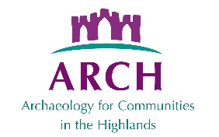

Project Funding Workshop: Useful websites

Funding Scotland https://funding.scot/
Directory of funding sources set up by SCVO. Although some entries have limited info, search on funding source directly to get full details.

National Heritage Lottery Fund grants
https://www.heritagefund.org.uk/funding/priorities-national-lottery-grants-heritage
Three tiers. All applications via a portal which has the help notes and guidance. Recommended to submit enquiry form first to get initial feedback.

Historic Environment Scotland grants www.historicenvironment.scot/grants-and-funding
Submit Expression of Interest form first. Most programmes with set closing dates.

Museums and Galleries Scotland www.museumsgalleriesscotland.org.uk/funding/
Two tiers, with set closing dates. Mainly for accredited museums only. Applications via online portal, but sample applications available from the website.

National Lottery Scotland
https://www.tnlcommunityfund.org.uk/funding/programmes?location=scotland
Some programmes for Scotland, where the focus is not simply heritage. Mixture of set deadlines and rolling applications.

Foundation Scotland https://www.foundationscotland.org.uk/
A variety of funding programmes, including administering some of the windfarm benefit schemes.

Inspiring Fundraising Toolkit https://inspiringfundraising.co.uk/
Set up as a legacy of Resourcing Scotland’s Heritage programme which finished in 2018. More background, and arguably more useful to bigger organisations/projects.

What Works Wellbeing https://measure.whatworkswellbeing.org/
Recommended by NLHF for how to measure well being if you choose this as an outcome

NLHF Evaluation Guidance
https://www.heritagefund.org.uk/funding/good-practice-guidance/evaluation-guidance
Comprehensive discussion on how to evaluate outcomes

Date of document: v. 1 July 2022

